Electronic label image production

In the test phase, you can manually create an image of the electronic label. The method of making it is as follows:

1. Make BMP format pictures

2. Converted BMP format picture to a JSON message.

# Make BMP format pictures

For 4.2-inch electronic tags, it is recommended that the supporting version of the base station be V1.3.

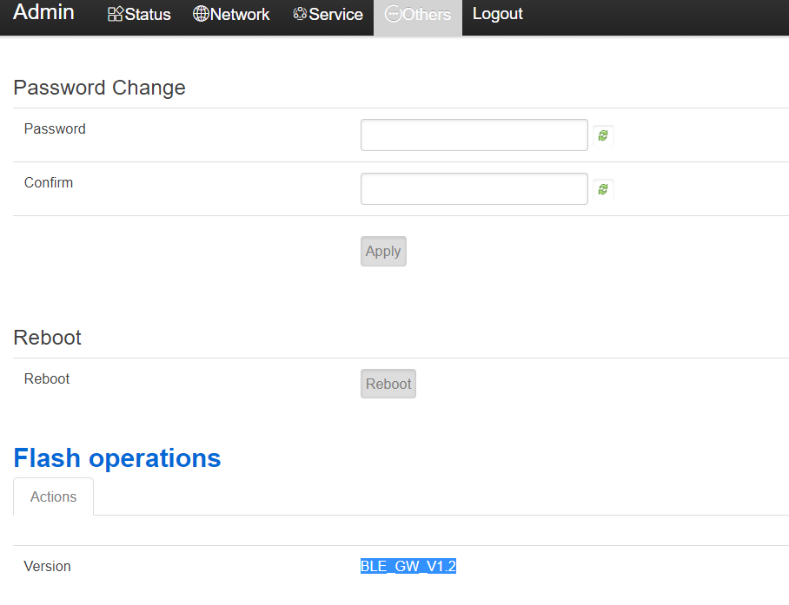

This screen does not support gray scale. When making pictures, you need to make a pure black and white picture with 400*300 resolutions.

The following uses the windows drawing tool as an example:

1, Windows attachment menu = "painting

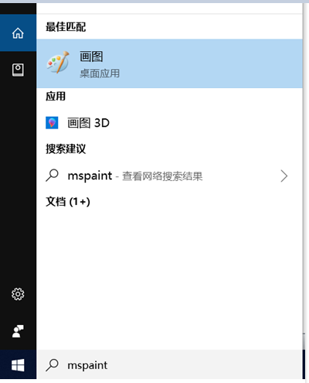

2. set the resolution to 400*300

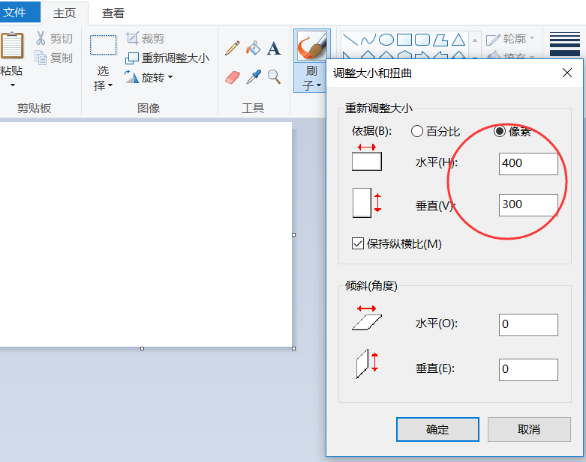

3. you can add text on the picture.

4. please select the single color bitmap to save.

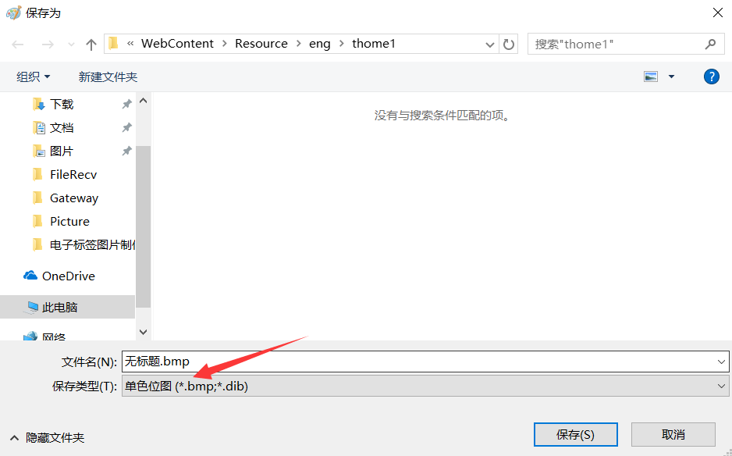

# Converted BMP format picture to a JSON message

## Step By Step to generate JSON message

1. Please put the BIN files generated in the previous step and Bmp2EslJson.exe in the same directory.

2. Run the Bmp2EslJson.exe tool, the parameters you need to enter are as follows:

1. BIN file name.
2. ESL type: esl29
3. Passoword: the default password is “00000000”
4. Mac address : The mac address of the ESL can be viewed through the gateway status monitoring to the 12-character mac address.
5. Picture ID: you can enter a number, this is equivalent to the number of this picture. If json message download to ESL success, the picture id will include in status report.
6. JSON Message ID: identify about the json message, every download message should be different.
7. Whether compression: y

After the return, you will be prompted to write the JSON file successfully. You can see that a file named lcd42_examp1.json is generated in the same directory, which is the image update message.

Bmp2EslJson.exe is based on Visual Studio 2012 written in C language. The source code can be downloaded at the following URL:

https://github.com/kkmhogen/Bmp2EslJson.git

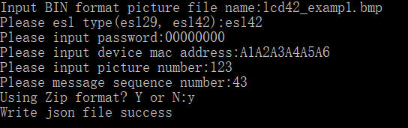

## One command generate JSON message

1. Please put the BIN files generated in the previous step and Bmp2EslJson.exe in the same directory.

2. Execute following command

Bmp2EslJson.exe -f goods2.bmp -t e42 -p 00000000 -m 0C23CAF98100 -id 1478 -s 123 -z y

After the command is executed successfully, a JSON file will be generated. If the execution fails, a prompt error will be generated.

Paramaters:

-f: file name

-t: esl type: esl42

-p: password

-m: mac address

-id: picture id

-s: json message id

-z: compress mode, y means compress, n means not compress